**DATA BASE PROJECT REPORT**

**(Programmatic tv)**

**Name: Danish Yaqub (2020104)**

**Name: Izhan Shaur (2020186)**

**Name: Armaghan malik (2020082)**

**Project Overview:** Designing an Advertising Management Database System(Programmatic tv)

**Introduction:**

In today's digital age, effective advertising management is crucial for businesses to reach their target audience and maximize their marketing efforts. An advertising management database system serves as the backbone for organizing, storing, and managing advertising-related data, catering to the needs of both advertisers and publishers. This project aims to design and implement such a system, leveraging theoretical knowledge to address practical scenarios and enhance skills in database design, development, and management.

**Understanding the Business Need:**

The first step in this project is to conduct a thorough analysis of the advertising management landscape. This involves understanding the requirements and challenges faced by advertisers and publishers in managing their advertising campaigns. Key considerations include:

**User Authentication:** Providing secure login functionality for both advertisers and publishers to access the system.

**Slot Booking:** Allowing publishers to book and unbook advertising slots, ensuring efficient utilization of advertising inventory.

**Advertisement Parameters:** Enabling advertisers to input parameters such as prime time, budget, date, gender targeting, and types of news channels for their advertising campaigns.

**Data Management:** Implementing a robust database structure to store and organize user information, advertisement slots, booking records, and targeting parameters.

**Querying and Reporting:** Developing functionalities for querying the database and generating reports to analyze advertisement performance and user engagement metrics.

**Business Scenario Analysis:** Identifying the Need for an Advertising Management Database System

In today's highly competitive business environment, effective advertising management is paramount for businesses to reach their target audience and achieve marketing success. However, managing advertising campaigns efficiently and maximizing their impact poses several challenges for both advertisers and publishers. A database management system (DBMS) tailored to address the advertising management needs of both parties can provide significant value by streamlining operations, improving decision-making processes, and enhancing overall efficiency.

**Advertiser Perspective:**

Advertisers, whether small businesses or large corporations, face numerous challenges when planning and executing advertising campaigns. These challenges include:

**Target Audience Identification**: Advertisers need to identify their target audience accurately to ensure that their advertisements reach the right demographics and maximize ROI.

**Budget Management:** Managing advertising budgets effectively is crucial for optimizing campaign performance and ensuring that resources are allocated efficiently.

**Advertisement Placement:** Selecting the right advertising channels and placements (e.g., prime time slots, specific news channels) is essential for reaching the intended audience and maximizing exposure.

**Performance Tracking:** Advertisers require tools to track the performance of their advertisements, including metrics such as impressions, clicks, conversions, and return on investment (ROI).

**Data Analysis and Insights:** Analyzing advertising data and extracting actionable insights is crucial for refining advertising strategies and improving campaign effectiveness over time.

**Publisher Perspective:**

Publishers, such as television networks or online platforms, also face unique challenges in managing advertising inventory and maximizing revenue potential. These challenges include:

**Inventory Management:** Publishers need to manage their advertising inventory efficiently, ensuring that available slots are booked and utilized effectively to maximize revenue.

**Slot Booking and Allocation:** Providing advertisers with a seamless process for booking and unbooking advertising slots is essential for maintaining smooth operations and meeting client needs.

**Targeting Capabilities:** Offering targeting options such as prime time slots, specific audience demographics, and preferred news channels can attract advertisers and enhance the value of advertising inventory.

**Revenue Optimization:** Maximizing advertising revenue requires publishers to strike a balance between demand and supply, optimizing pricing strategies and allocation of advertising slots.

**Performance Reporting:** Providing advertisers with comprehensive reports on advertisement performance and audience engagement is essential for building trust and fostering long-term partnerships.

**ERD design**

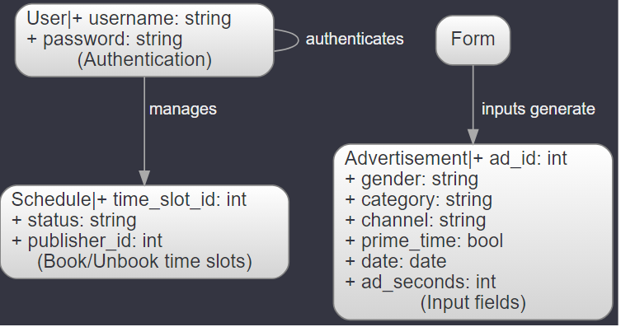

**Data population**

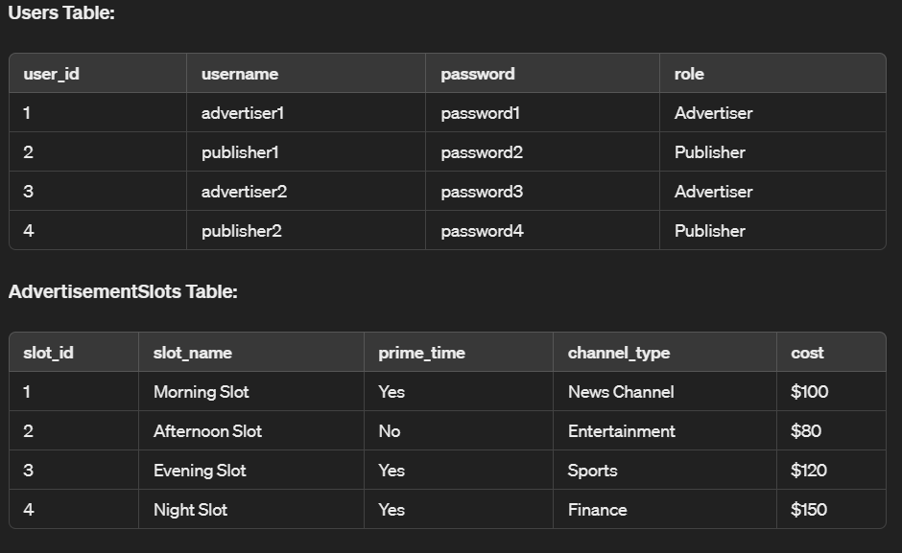

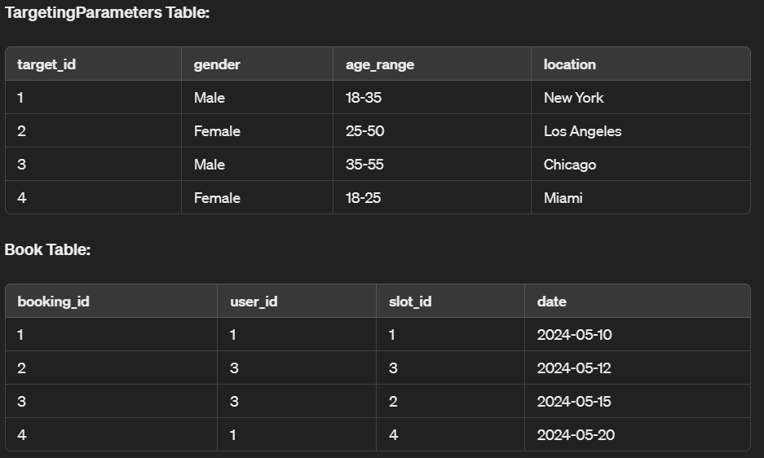

This sample data provides a starting point for testing and demonstration purposes. It includes mock user profiles for advertisers and publishers, advertisement slots with different characteristics, targeting parameters for demographic segmentation, and booking records to simulate advertisement placements.

**Querying and Reporting**

**Query: List all available advertisement slots:**

SELECT * FROM AdvertisementSlots;

**Query: List all bookings made by a specific advertiser (e.g., advertiser with user_id = 1):**

SELECT * FROM Book WHERE user_id = 1;

**Query: List all bookings for a specific date (e.g., 2024-05-15):**

SELECT * FROM Book WHERE date = '2024-05-15';

**Query: Calculate the total cost of bookings made by a specific advertiser (e.g., advertiser with user_id = 3):**

SELECT SUM(cost) AS total_cost

FROM Book

JOIN AdvertisementSlots ON Book.slot_id = AdvertisementSlots.slot_id

WHERE user_id = 3;

**Query: Generate a report showing the number of bookings made for each advertisement slot:**

SELECT slot_name, COUNT(*) AS bookings_count

FROM Book

JOIN AdvertisementSlots ON Book.slot_id = AdvertisementSlots.slot_id

GROUP BY slot_name;

**Query: Retrieve targeting parameters for a specific advertisement slot (e.g., slot_id = 2):**

SELECT * FROM TargetingParameters WHERE slot_id = 2;

**Query: Generate a report showing the total revenue generated from bookings for each channel type:**

SELECT channel_type, SUM(cost) AS total_revenue

FROM Book

JOIN AdvertisementSlots ON Book.slot_id = AdvertisementSlots.slot_id

GROUP BY channel_type;

**Query: List advertisers who have booked prime time slots:**

SELECT DISTINCT Users.username

FROM Users

JOIN Book ON Users.user_id = Book.user_id

JOIN AdvertisementSlots ON Book.slot_id = AdvertisementSlots.slot_id

WHERE AdvertisementSlots.prime_time = 'Yes' AND Users.role = 'Advertiser';

**Query: Retrieve demographic targeting parameters for a specific advertisement slot (e.g., slot_id = 1):**

SELECT * FROM TargetingParameters WHERE slot_id = 1;

**Query: Generate a report showing the total number of bookings made by each advertiser:**

SELECT Users.username AS advertiser, COUNT(*) AS total_bookings

FROM Users

JOIN Book ON Users.user_id = Book.user_id

WHERE Users.role = 'Advertiser'

GROUP BY Users.username;

**User interface**

